Method : **GET**

Status : 200 OK

URL : https://www.localhost:3010/**users**

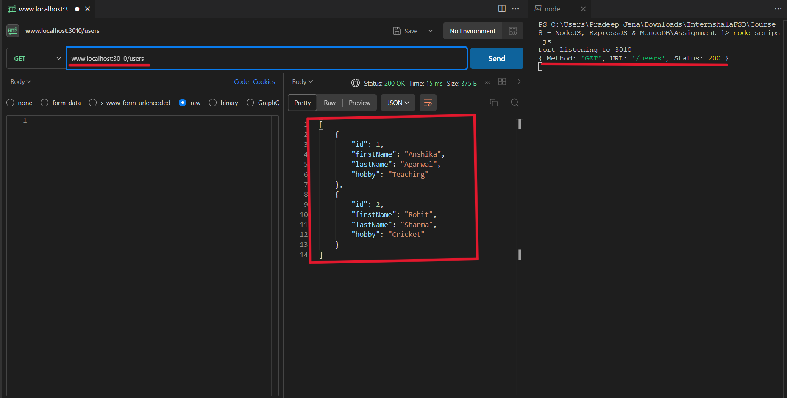

Method : **GET**

Status : 200 OK

URL : https://www.localhost:3010/**users/2**

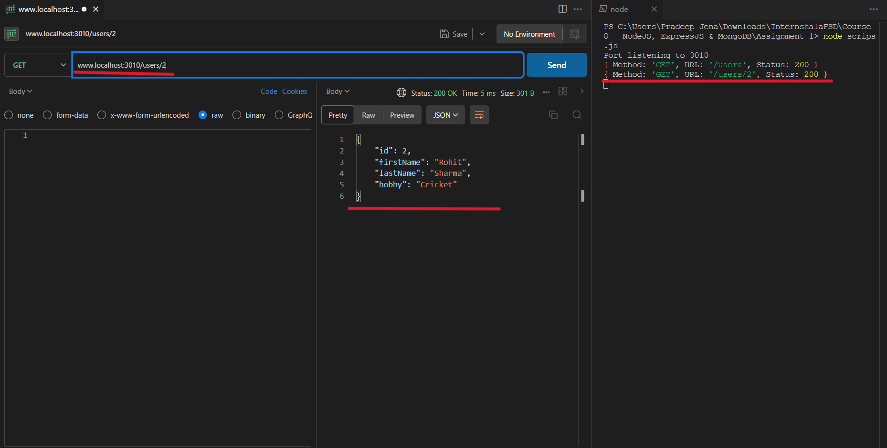

Method : **GET**

Status : 404 - “User not found”

URL : https://www.localhost:3010/**users/32**

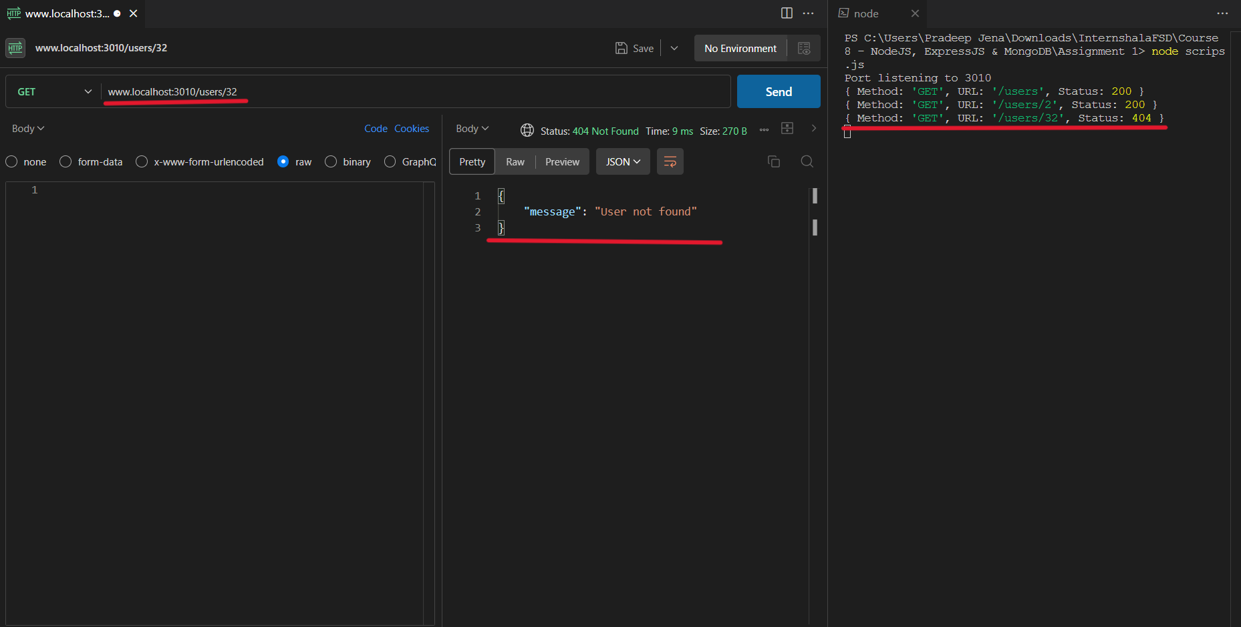

Method : **POST**

Status : 201

URL : https://www.localhost:3010/**user**

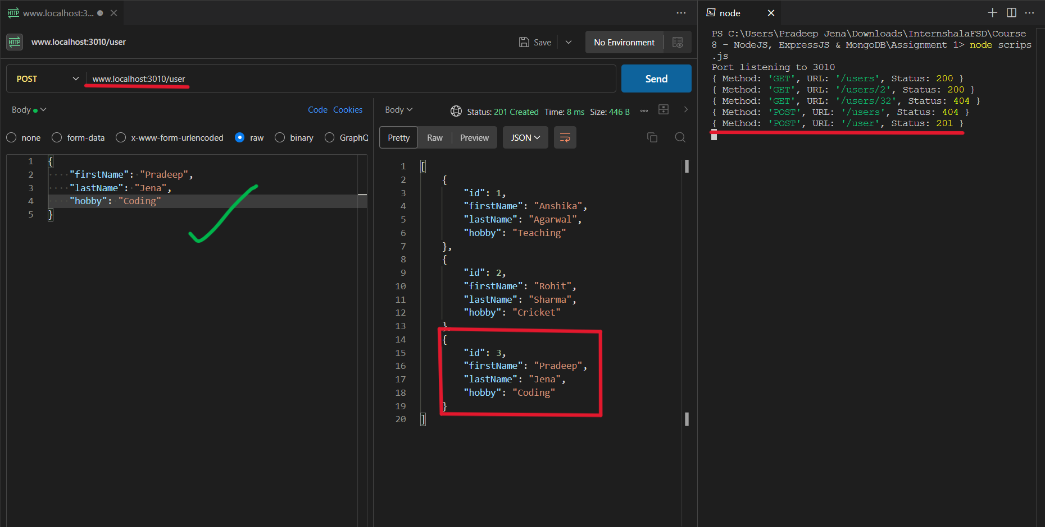

Method : **POST**

Status : 401 - Please provide all the fields

URL : https://www.localhost:3010/**user**

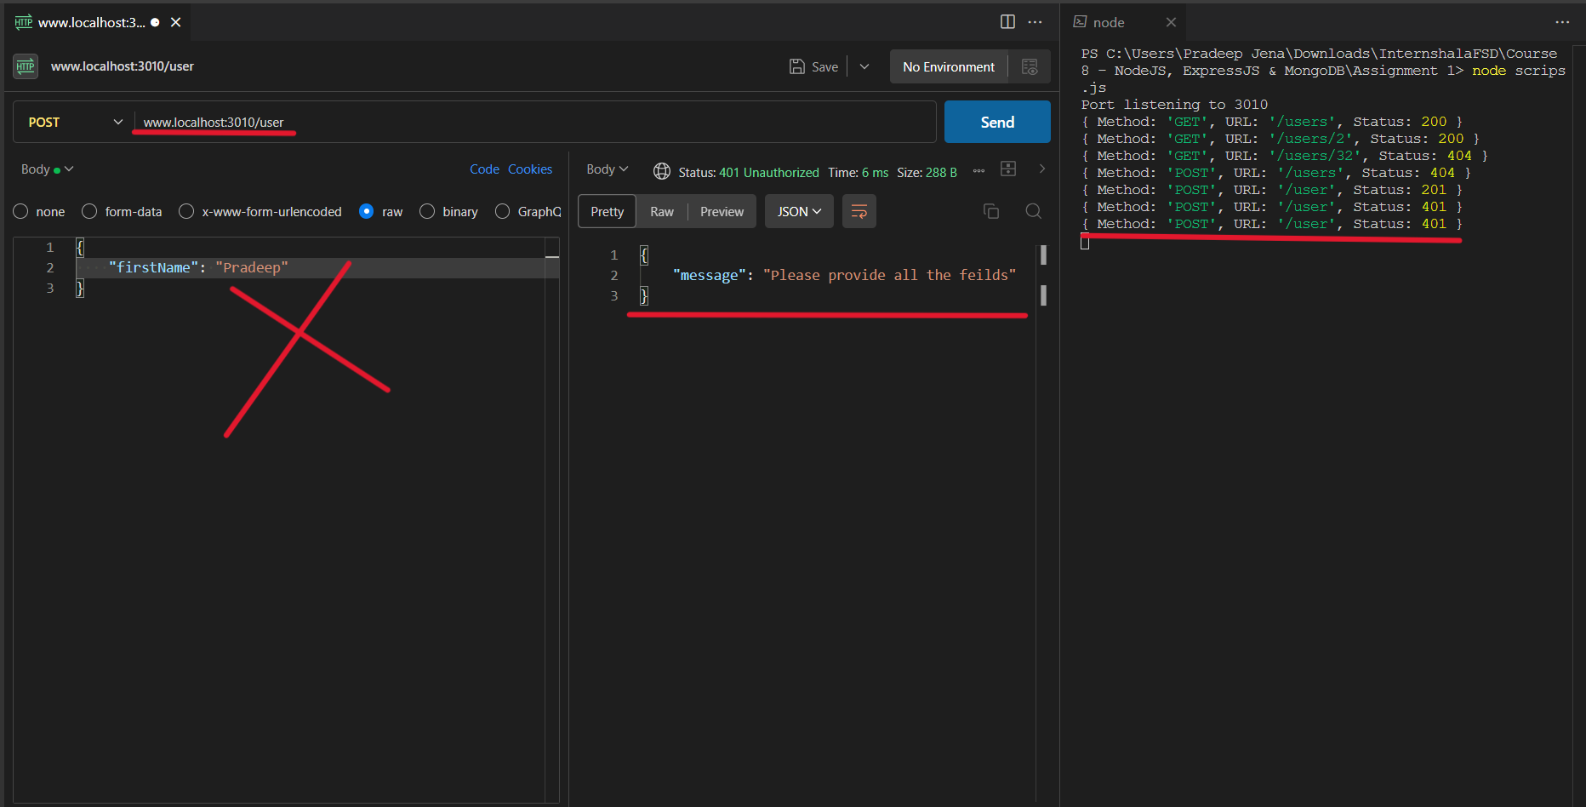

Method : **PUT**

Status : 200

URL : https://www.localhost:3010/**users/2**

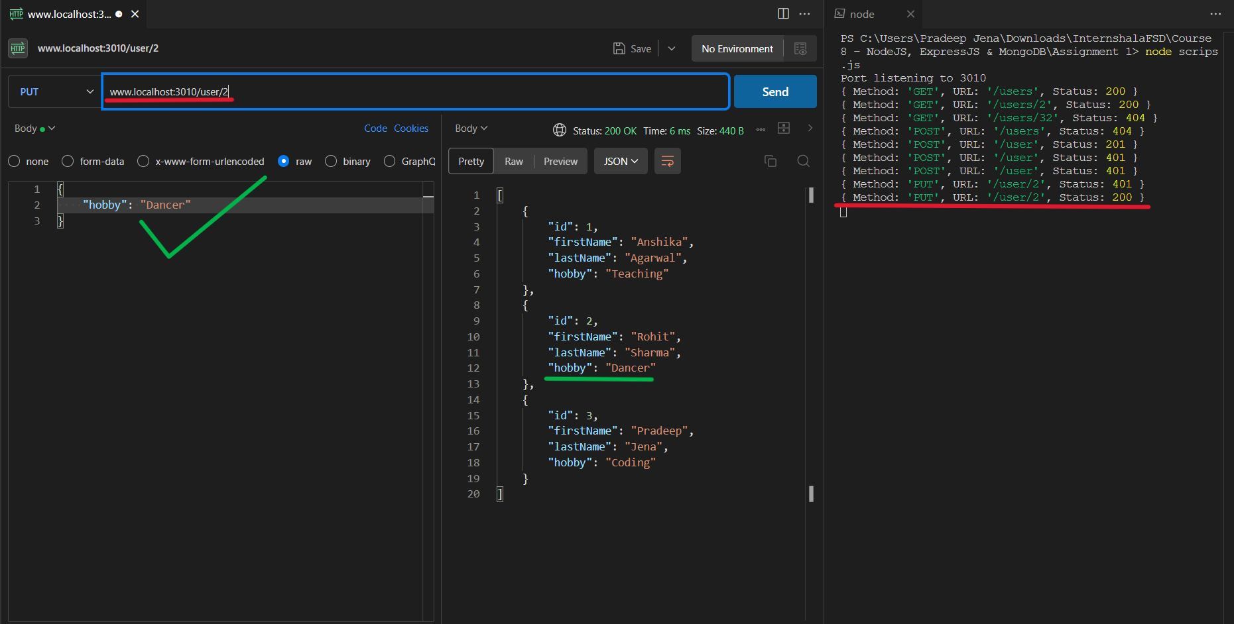

Method : **PUT**

Status : 401 - No details provided to update

URL : https://www.localhost:3010/**users/2**

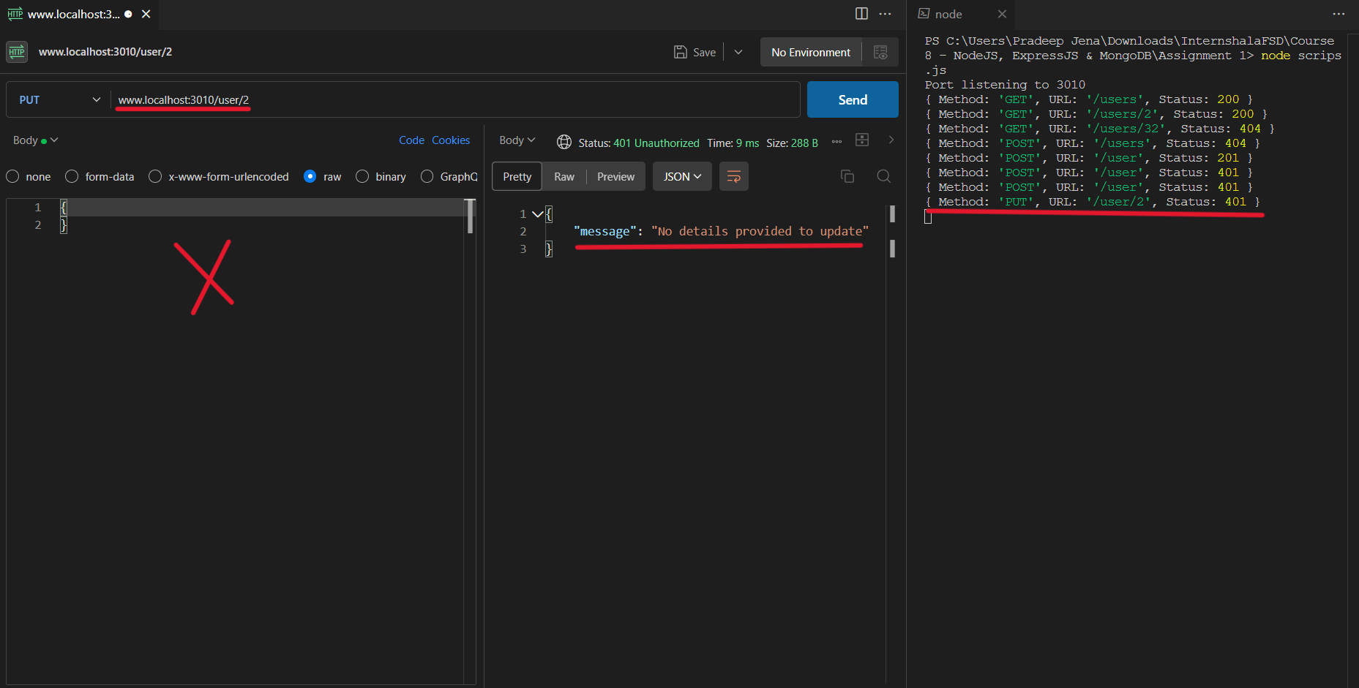

Method : **DELETE**

Status : 200

URL : https://www.localhost:3010/**users/2**

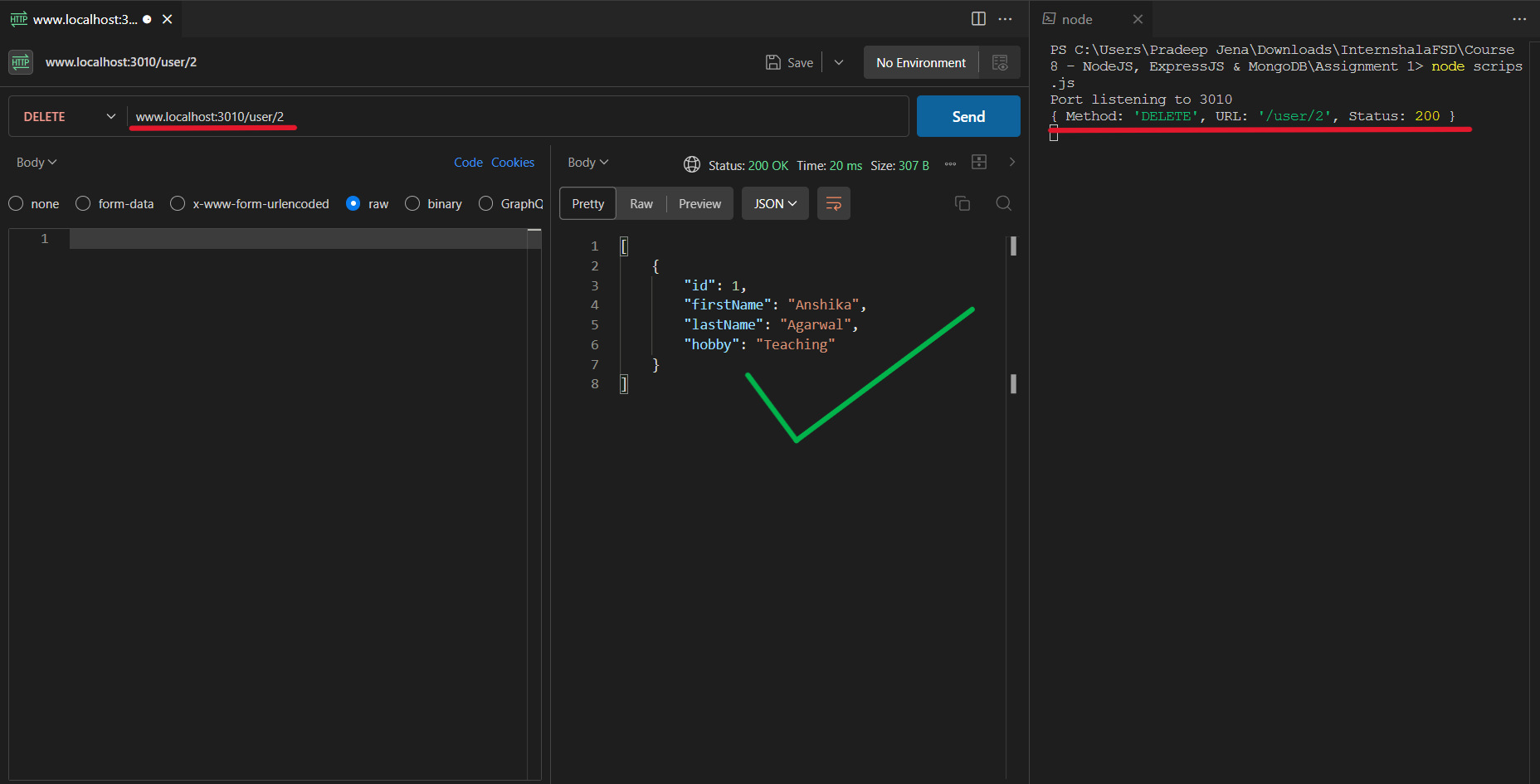

Method : **DELETE**

Status : 404 - User not found

URL : https://www.localhost:3010/**users/20**

